# Lab 01 - Manage Azure Active Directory Identities

**Student lab manual**

***Mihail Elencevski***

#### Task 1: Create and configure Azure AD users

*In this task, the goal is to create two user accounts, named az104-01a-aaduser1 and az104-01a-aaduser2, in Azure AD and configure them with basic information such as display names and email addresses. These users will later be added to two different groups in order to manage their access to specific resources.*

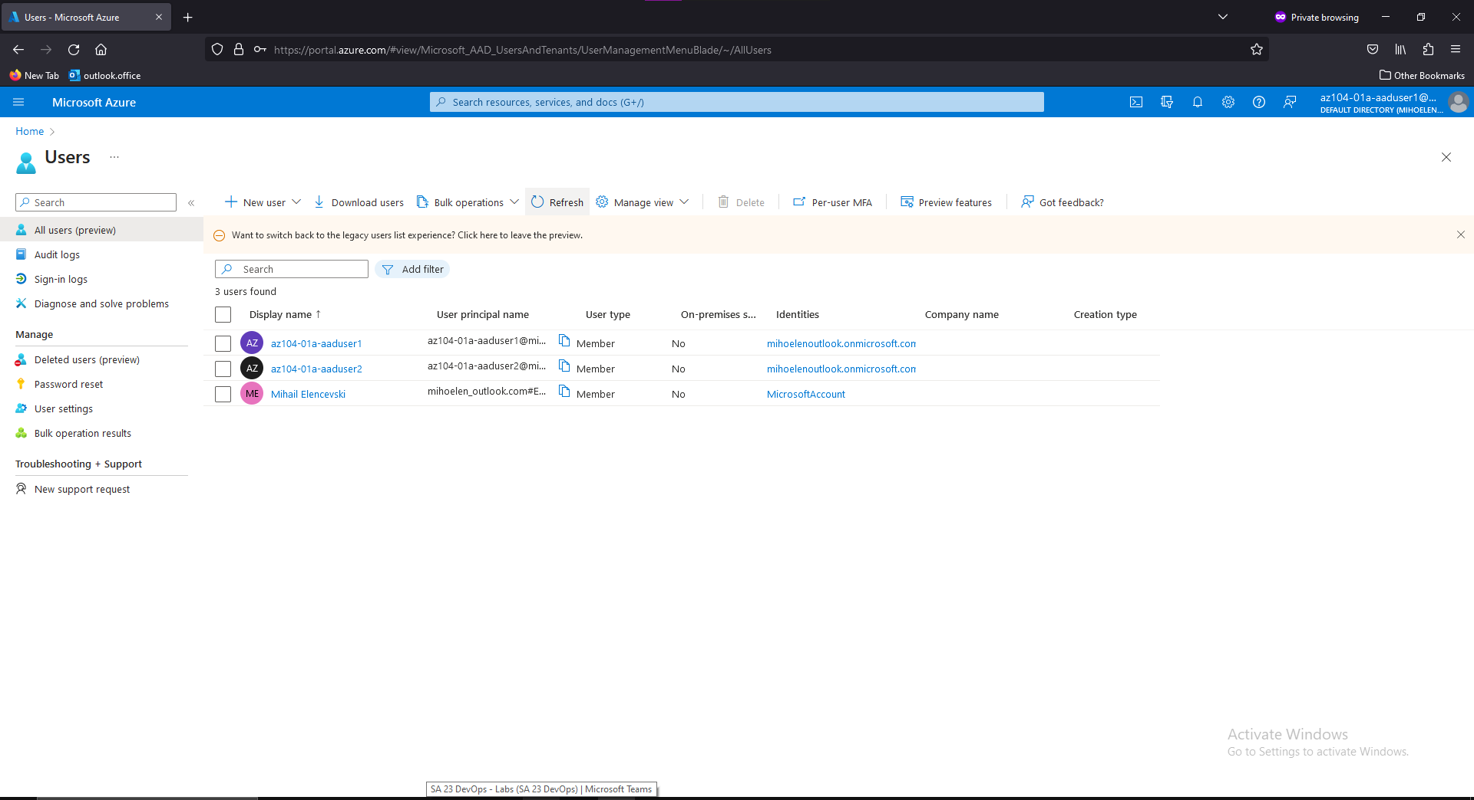

#### Task 2: Create Azure AD groups with assigned and dynamic membership

*In this particular scenario, the task is to create Azure AD groups with both assigned and dynamic membership. Assigned membership involves manually adding individual users to a group, while dynamic membership involves defining rules that automatically add or remove users based on specific criteria.*

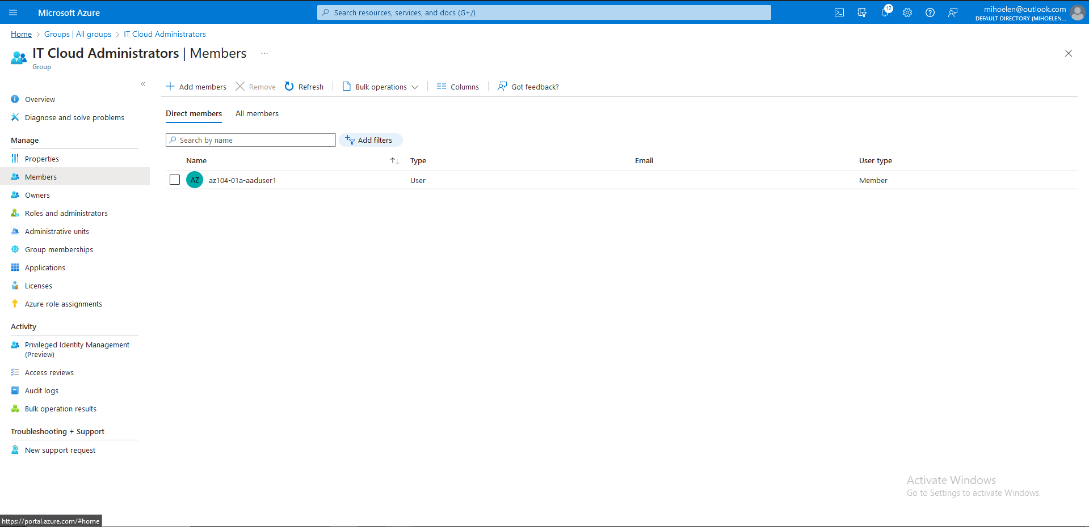

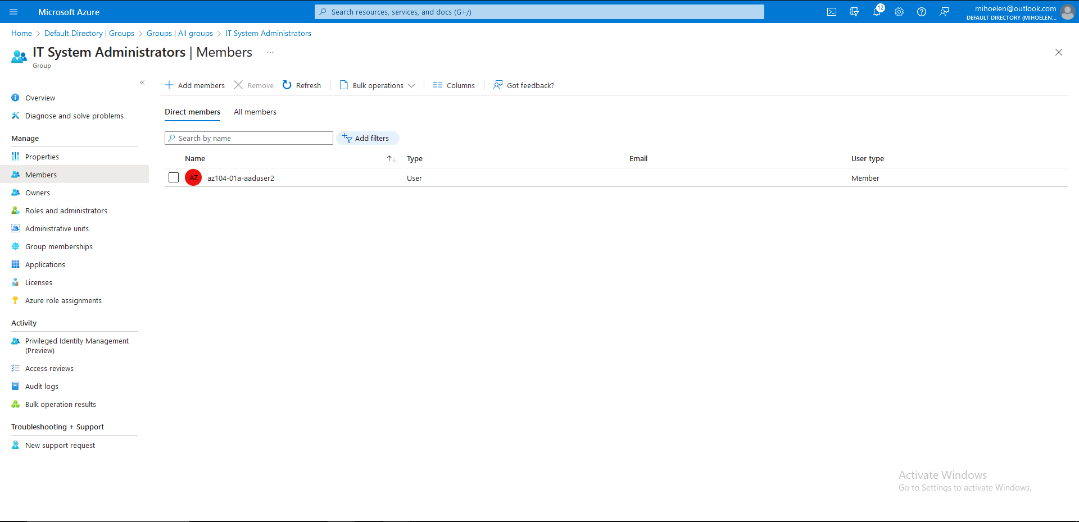

#### Task 3: Create an Azure Active Directory (AD) tenant (Optional - Lab environment issue)

*In this scenario, the task is to create an Azure AD tenant. This process involves setting up a new instance of Azure AD within an Azure subscription, configuring the tenant's basic settings, and creating user accounts and groups as needed.*

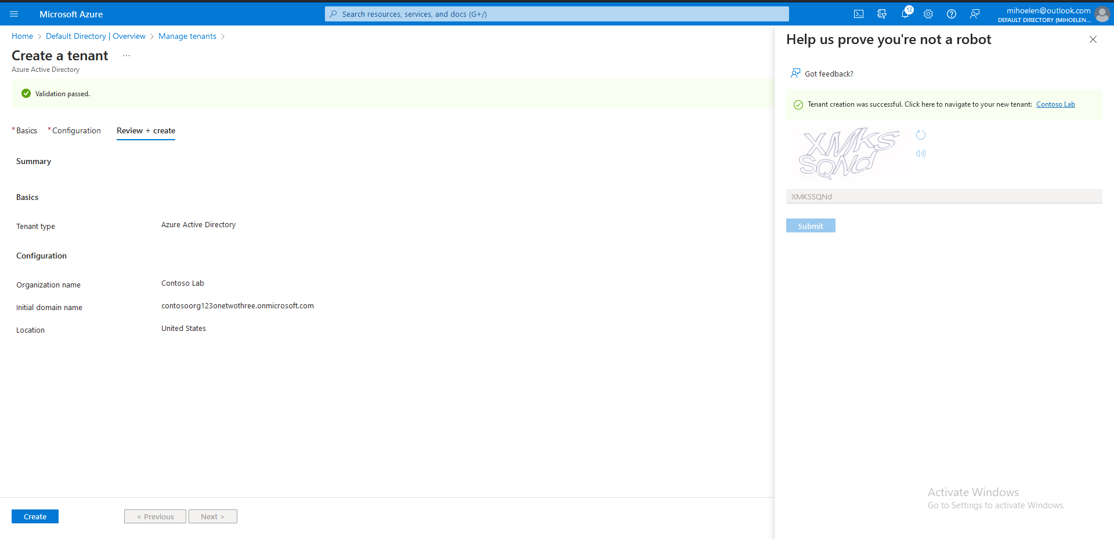

#### Task 4: Manage Azure AD guest users.

*In this task we have to manage Azure AD guest users. This involves creating guest user accounts, granting them access to specific resources within the Azure environment, and managing their permissions and access as needed.*

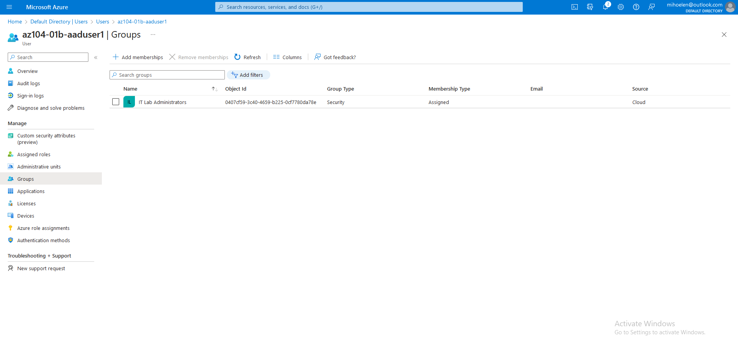

#### Task 5: Clean up resources

